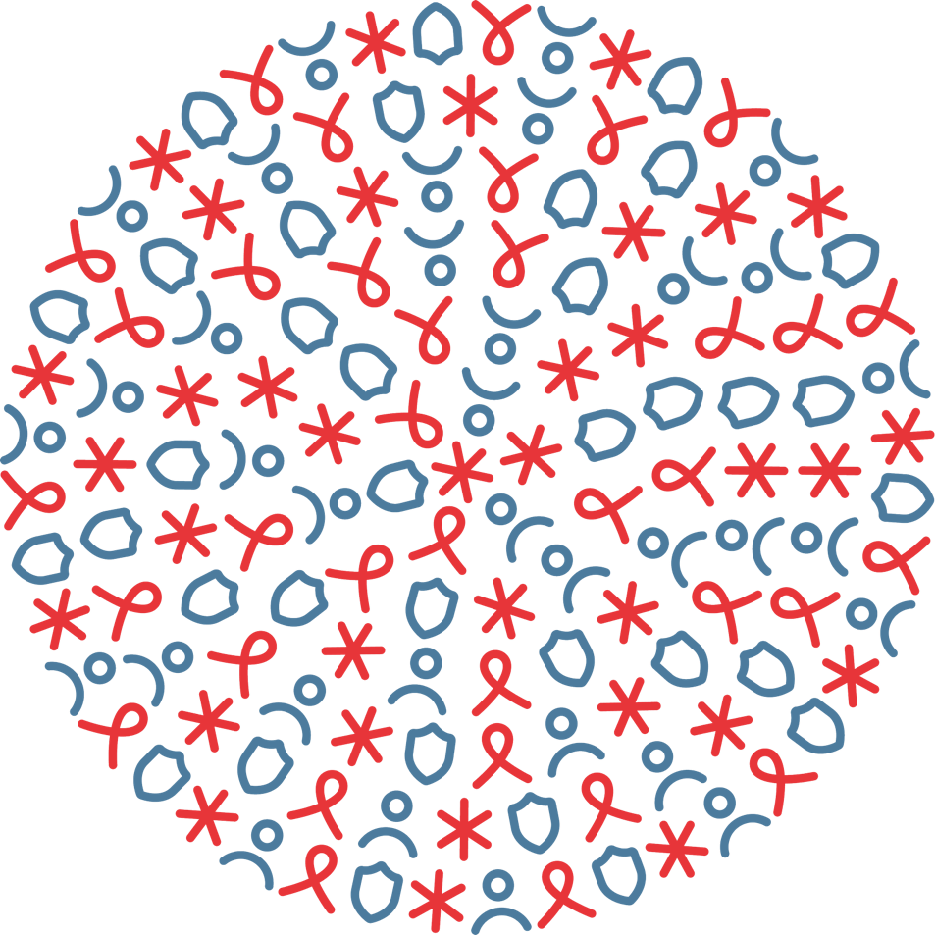
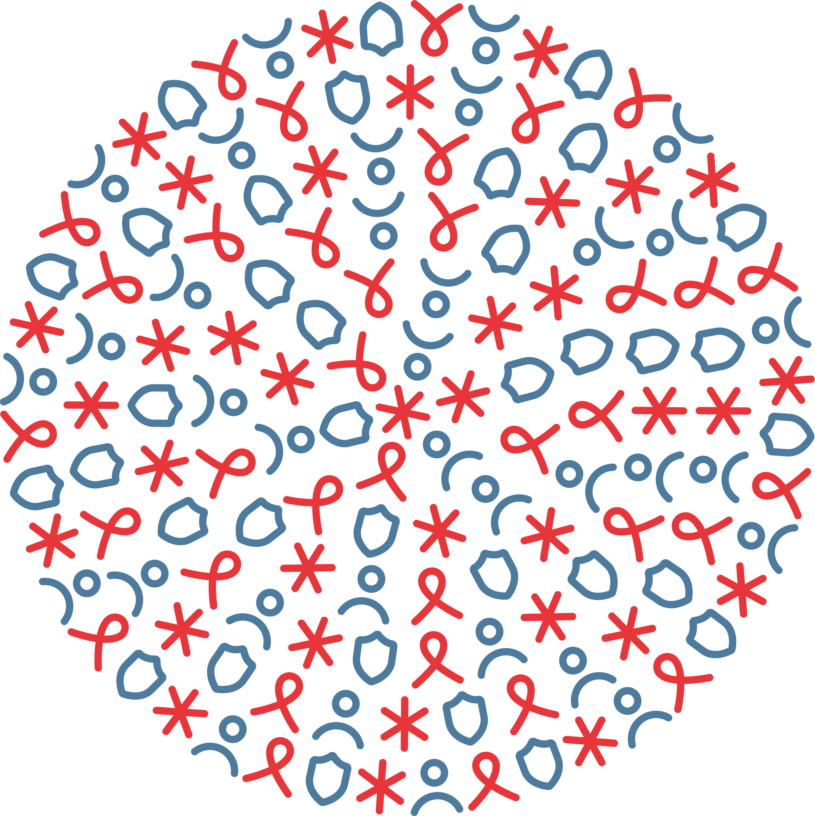
FUNDING STREAMS:
HIV, GHS, MNCH, Nutrition, Malaria, COVID-19

OCTOBER 1, 2025 TO MARCH 31, 2026
SUBMITTED BY FHI 360:
MAY 20, 2026
DEMOCRATIC REPUBLIC OF THE CONGO
SEMI-ANNUAL PROGRESS REPORT
Meeting targets and maintaining epidemic control (epic) project

cOoperative agreement no.
7200AA19CA00002




Contents
Acronyms i
Executive Summary 1
I. Key Results by Objective Per Technical Area 1
A. Maternal, Newborn, and Child Health 1
B. Nutrition 2
C. Malaria 2
II. Management and Operations 2
III. Success Stories 5
MATERNAL, NEWBORN, CHILD HEALTH / NUTRITION / MALARIA 5
IV. Challenges 6
MATERNAL, NEWBORN, CHILD HEALTH / NUTRITION / MALARIA 6
V. Priority Activities in the Next Six Months (April to September 2026) by Technical Area 8
Maternal, Newborn, and Child Health 8
Nutrition 9
Malaria 9
Annex B: MNCH, Nutrition, and Malaria Performance Monitoring and Evaluation Matrix 10
Annex C: GHS Performance Monitoring and Evaluation Matrix 12

Acronyms
ACT  AFGHS  AHD  ANC  ART  ARV  BPC  BSS  CBS  CHAI  CUK  DATIM  DHIS2  DQA  DRC  EID  EMCE  EmONC  EMR  EpiC  EVD  FHI 360  FY  GAS  GeneXpert  GHS  GHSC-PSM  GoDRC  GTOM  HCW  HIS  HIV  HIVST  HKI  HRH  HZ  iCCM  IHA  IP  IPC  IPTp  IPTp3  IYCF  LLIN  LMD  LNS  LOX  M&E  MCH  MER  MHPSS  MNCH  MNP  MoH  MOU  Mpox  MSA  OVC  pALD  PAMOJA  PBW  PEPFAR  PITC  PLHIV  PMTCT  PNLS  PNC  POC  PoC  PPE  PPH  PrEP  PRONANUT  PSA  RCCE  RDT  RDQA  RECO  SDB  SI  SMS  SOP  SOW  TB  UNICEF  USG  VHF  VL  WASH | Artemisinin-based Combination Therapy  America First Global Health Strategy  Advanced HIV Disease  Antenatal Care  Antiretroviral Therapy  Antiretroviral  Provincial Coordinating Office (Bureau Provincial Coordinateur)  Biosafety and Biosecurity  Community-Based Surveillance  Clinton Health Access Initiative  University Clinics of Kinshasa  Data for Accountability, Transparency, and Impact Monitoring  District Health Information System 2  Data Quality Assessment  Democratic Republic of the Congo  Early Infant Diagnosis  Evidence-Based Public Health Messaging and Community Engagement  Emergency Obstetric and Newborn Care  Electronic Medical Record  Meeting Targets and Maintaining Epidemic Control  Ebola Virus Disease  Family Health International 360  Fiscal Year  Gestion des Approvisionnements et Stocks  GeneXpert MTB/RIF  Global Health Security  Global Health Supply Chain Program - Procurement and Supply Management  Government of the Democratic Republic of the Congo  Ministry of Health’s Oxygen Working Group  Health Care Worker  Health Information Systems  Human Immunodeficiency Virus  HIV Self-Testing  Helen Keller International  Human Resources for Health  Health Zone  Integrated Community Case Management  Integrated Health Area  Implementing Partner  Infection Prevention and Control  Intermittent Preventive Treatment in Pregnancy  Intermittent Preventive Treatment in Pregnancy - 3 doses  Infant and Young Child Feeding  Long-Lasting Insecticidal Net  Last Mile Distribution  Lipid-based Nutrient Supplement  Liquid Oxygen  Monitoring and Evaluation  Maternal and Child Health  Monitoring, Evaluation, and Reporting  Mental Health and Psychosocial Support  Maternal, Newborn, and Child Health  Micronutrient Powder  Ministry of Health  Memorandum of Understanding  Monkeypox  Memorandum of Service Agreement  Orphans and Vulnerable Children  Pediatric Advanced HIV Disease  PEPFAR Africa Monitoring Joint Application  Pregnant and Breastfeeding Women  U.S. President's Emergency Plan for AIDS Relief  Provider-Initiated Testing and Counseling  People Living with HIV  Prevention of Mother-to-Child Transmission  National AIDS Control Program (Programme National de Lutte contre le SIDA)  Postnatal Care  Point of Care  Point of Control  Personal Protective Equipment  Postpartum Hemorrhage  Pre-Exposure Prophylaxis  National Nutrition Program (Programme National de Nutrition)  Pressure-swing Absorption  Risk Communication and Community Engagement  Rapid Diagnostic Test  Routine Data Quality Assessment  Relais Communautaire (Community Health Worker)  Safe and Dignified Burial  Strategic Information  Short Message Service  Standard Operating Procedure  Scope of Work  Tuberculosis  United Nations Children's Fund  United States Government  Viral Hemorrhagic Fever  Viral Load  Water, Sanitation, and Hygiene

Executive Summary
During the first half of Fiscal Year (FY) 2026 (October 2025–March 2026), the Meeting Targets and Maintaining Epidemic Control (EpiC) project delivered comprehensive lifesaving health interventions across Human Immunodeficiency Virus (HIV), maternal, newborn, and child health (MNCH), nutrition, malaria, and global health security (GHS), directly supporting Government of the DRC (GoDRC) priorities, United States Department of State guidance, and the America First Global Health Strategy (AFGHS). Aligned with the AFGHS emphasis on sustainable, country-led health systems and bilateral cooperation, EpiC strengthened surveillance and data systems, expanded domestic capacity through workforce development and infrastructure investments, and prioritized frontline commodities and health workers to achieve measurable health outcomes. The program operated in the Lualaba and Haut-Katanga provinces for HIV, four provinces (Haut-Katanga, Lualaba, Kasaï-Oriental, and Lomami) for integrated malaria-MCH-nutrition interventions, and strategic outbreak response zones in Kinshasa, Equateur, Lualaba, and Kasaï provinces for GHS, demonstrating coordinated implementation that reinforces national health system resilience, enhances epidemic preparedness, and advances the transition toward greater domestic ownership and self-reliance.

Key Results by Objective Per Technical Area

Maternal, Newborn, and Child Health
EpiC reinforced lifesaving MNCH interventions across four provinces—Haut-Katanga, Lualaba, Kasai Oriental, and Lomami—through coordinated implementation and integrated technical support. The program:
- Supported 102,846 pregnant women to complete at least four antenatal care (ANC) visits (57.5%)
- Facilitated 148,965 skilled birth deliveries (83.3%)
- Ensured postnatal care (PNC) for 135,956 newborns (89.6%)
- Treated 65,943 childhood diarrhea cases, contributing directly to improved maternal and child survival outcomes
- Supported 148,345 children under 12 months to receive three doses of the pentavalent vaccine (95.1%)
- Reached 1,567 additional children through catch-up vaccination efforts led by community health workers (or Relais Communautaire (RECOs))
- Capacitated 508 health providers through training and mentorship in childbirth care and neonatal resuscitation.
- Convened coordination meetings with the Ministry of Health (MoH), Department of State, UNICEF, Save the Children, Helen Keller International (HKI), and other partners to harmonize interventions, strengthen integrated supervision systems, and align maternal health priorities with national strategies.
These achievements reflect strong alignment with government priorities and demonstrate measurable progress toward strengthening sustainable, locally led health service delivery systems.

Nutrition
- Expanded equitable access to lifesaving nutrition interventions through integrated implementation and strengthened supervision systems across the four target provinces.
- Supported the delivery of Vitamin A supplementation and deworming to 2,496,124 children under five
- Distributed 187,200 Lipid-based Nutrient Supplement (LNS) sachets to 11,118 children aged 6-24 months
- Delivered 486,800 Micronutrient Powder sachets to 2,000 PBW, directly contributing to improved child survival and maternal nutrition outcomes
- Convened coordination meetings with the National Nutrition Program (PRONANUT) and provincial authorities to harmonize nutrition planning, improve commodity quantification, and strengthen oversight mechanisms.
These interventions demonstrate sustained commitment to strengthening frontline service delivery and building resilient nutrition systems in alignment with national health priorities and the AFGHS emphasis on measurable health outcomes and country ownership.

Malaria
- Delivered focused malaria interventions on lifesaving case management, prevention, and strengthened supply chain and data systems across the four target provinces.
- Reported 1,006,236 suspected malaria cases – of which 972,866 were tested for malaria to support timely diagnosis and treatment – and treated 559,420 confirmed malaria cases with artemisinin-based combination therapy (ACT), out of 645,625 confirmed cases, contributing to reduced morbidity and mortality
- Strengthened and equipped 1,372 integrated Community Case Management (iCCM) sites to expand access to community-based malaria services
- Distributed 120,414 long-lasting insecticidal nets (LLINs) to pregnant women as well as IPTp to health facilities, ensuring 107,441 pregnant women received their intermittent preventive treatment in pregnancy (IPTp3) to reinforce malaria prevention.
- Developed rapid assessment tools for malaria services to improve monitoring and service quality.
These achievements demonstrate effective integration of malaria interventions with broader MNCH services and reflect progress toward building sustainable, country-led malaria response capacity.

Management and Operations
During the reporting period (October 2025-March 2026), EpiC successfully advanced critical operational milestones across HIV, MNCH, nutrition, malaria, and GHS programs. The project demonstrated strong adaptive management capacity, maintaining implementation continuity for established programs while simultaneously launching new integrated interventions following workplan approvals. Strategic investments in human resources, infrastructure, procurement systems, and partnership development positioned the program for accelerated implementation and sustained impact in the second half of FY26.
Procurement and Logistics
- Supported procurement and deployment of laboratory equipment (refrigerators, freezers, centrifuges, computers), cold chain infrastructure, and data management systems to improve hub and POC readiness for VL/EID services, addressing critical gaps identified through laboratory assessments.
- Managed emergency mitigation measures for national stock-outs affecting HIV testing, VL, and EID commodities, including authorized emergency procurement, redistribution support between facilities, and tighter coordination with supply chain partners for LMD.
- Managed the procurement and deployment of cholera response kits to support intensive cholera control efforts along the Congo River corridor and in Lualaba mining communities, ensuring rapid availability of essential commodities for case management and outbreak containment.
- Standardized the procurement of Aquatabs and IPC kits, ensuring 100% compliance with national health protocols and USG quality standards, including rejection of non-compliant products and implementation of strengthened vendor qualification and product verification procedures.
- Distributed over 6,800 units of field equipment and communication tools (megaphones, Personal Protective Equipment (PPE), multi-lingual RCCE materials, vests, rubber boots, batteries) to frontline responders across GHS intervention zones, enabling effective outbreak response and community engagement activities.
- Initiated procurement planning for MNCH medicines, materials, and basic equipment to address persistent commodity shortages and strengthen service delivery capacity at health facilities across the four target provinces for the integrated program.
Subawards and Partnerships
- Developed subaward packages and advanced the subaward process for HIV program implementation to support implementation readiness, strengthen collaboration with local IPs Maison Faradja and Association Lamuka, and ensure timely operationalization of priority HIV activities in alignment with approved program objectives.
- Initiated preparatory work for subawards to engage local partners for integrated MNCH-nutrition-malaria implementation and reinforce provincial implementation capacity, including development of SOWs, budget frameworks, and partner assessment criteria.
- Developed and finalized subaward agreements with local IPs to decentralize CBS in the Equateur and Kinshasa cholera hotspots, enabling sustained community-level outbreak detection and response capacity.
- Developed MoUs with supported HZs to clarify roles, implementation commitments, performance expectations, and coordination arrangements for delivery of priority HIV lifesaving services, formalizing partnerships and accountability mechanisms.
Coordination and Stakeholder Engagement
- Conducted introductory missions and strategic coordination meetings with national and provincial stakeholders, including the MoH, Save the Children, HKI, Chemonics/GHSC-PSM, and Data.FI, to strengthen alignment, harmonize interventions, and establish collaborative implementation frameworks for the integrated MNCH-nutrition-malaria program.
- Strengthened coordination with the MoH through the formalization of technical working groups for GHS indicator tracking, ensuring regular dialogue, joint planning, and alignment of GHS interventions with national outbreak preparedness and response priorities.
- Maintained regular collaboration with PNLS, provincial health divisions, and laboratory partners to reinforce accountability, harmonize standards, and support the longer-term transition of HIV systems and responsibilities to country-led institutions.
- Participated actively in national and provincial coordination platforms for MNCH, nutrition, malaria, and GHS, contributing to joint planning, resource mobilization, gap analysis, and monitoring of national health program performance against targets.
Field Supervision and Quality Assurance
- Strengthened field supervision and accountability through targeted supportive supervision visits, DQAs, and joint reviews with HZ and provincial teams, providing on-site technical support and identifying operational bottlenecks for immediate corrective action.
- Conducted a joint HIV supportive supervision mission in Lualaba with the PNLS/BPC Provincial Medical Coordinator and Technical Assistant, and members of the EpiC technical field team (depending on the sites visited) to coach providers, verify tool use and data quality, assess pALD implementation, review commodity availability, evaluate the VL/EID sample referral system, and identify corrective actions to improve service quality.
- Protected program continuity in remote settings by emphasizing weekly microplanning, remote follow-up using available communication channels, and focused support to sites with connectivity and access constraints, ensuring sustained implementation despite geographic and infrastructure challenges.
Adaptive Management and Problem-Solving
- Demonstrated strong adaptive management capacity in response to concurrent public health emergencies (cholera, measles, Mpox outbreaks), balancing emergency response support with continuation of routine HIV, MNCH, nutrition, and malaria services through flexible resource allocation and integrated coordination mechanisms.
- Implemented emergency response protocols to address national commodity stock-outs, laboratory delays, and access constraints, including emergency procurement, sample collection campaigns, hub establishment, redistribution networks, and strengthened commodity monitoring systems.
- Adapted implementation strategies to address security constraints, staff turnover, and partner gaps through mobile outreach planning, rapid capacity building for newly appointed staff, strengthened documentation of standard operating procedures, and intensified coordination with available partners.
31, 2026.

Success Stories

MATERNAL, NEWBORN, CHILD HEALTH / NUTRITION / MALARIA
Integrated supervision as a driver of quality improvement and community engagement
In Kasaï-Oriental, integrated supervision has evolved from a routine monitoring activity into a high-impact quality improvement approach aligned with national Integrated Health Area (IHA) priorities. Through joint MoH-EpiC supervision missions in Lukamu, Bibanga, and Katanda I, provincial health teams, in close collaboration with the MoH, provided structured on-the-job mentorship focused on service quality, data use, and adherence to clinical standards. These interventions contributed to improvements in the delivery of essential MNCH services, including strengthened immunization performance and enhanced identification and follow-up of zero-dose and under-immunized children. The integration of supervision across MNCH, nutrition, and malaria services also improved continuity of care and reinforced the functionality of integrated service delivery platforms at facility and community levels. By strengthening provider competencies, reinforcing community linkages, and promoting data-driven decision-making, this approach contributed to improved service coverage and increased community trust in the health system. Importantly, the model demonstrates strong country ownership, with provincial authorities institutionalizing and leading integrated supervision as a core pillar of the IHA strategy.
Community-driven Vitamin A supplementation through awareness and engagement
EpiC supported the provinces in implementing large-scale awareness and service delivery campaigns to increase Vitamin A supplementation among children under five, using an integrated approach aligned with IHA principles. Health providers and RECOs conducted targeted outreach to caregivers – particularly young mothers – through community dialogues, counseling sessions, and routine service platforms. Beyond improving awareness of Vitamin A benefits and deficiency risks, these interventions contributed to strengthening demand for a broader package of child health services, including deworming, immunization, and nutrition screening. During the reporting period, more than 2.4 million children received Vitamin A supplementation, reflecting both improved commodity availability and increased community uptake. This integrated approach helped shift caregiver perception from viewing supplementation as a one-time intervention to recognizing it as part of a continuous, preventive child health package. The experience underscores the importance of combining supply-side readiness with sustained community engagement to drive utilization, improve child survival outcomes, and reinforce integrated service delivery under the IHA framework.
Revitalizing Integrated Community care site for Malaria Services provision in Haut-Katanga
In Kamiseshi village, located more than 12 kilometers from the nearest health facility in Kafubu HZ, families faced major challenges accessing timely healthcare services. Children with fever and pregnant women often depended on self-medication or traditional remedies due to the distance and cost of travel, increasing the risk of severe malaria and preventable deaths in the community. To help close this gap, the EpiC project revitalized an iCCM site that had previously been established under earlier USG-supported programs. EpiC supported the site through the provision of malaria commodities, management tools, essential equipment, and regular supportive supervision for RECOs. Following the revitalization, community-based service delivery quickly resumed. Between February-March, the iCCM site managed 58 children under 13 years of age according to national malaria treatment guidelines. Among them, 48 children presented with fever, 32 tested positive for malaria, and all confirmed cases received appropriate treatment. The restored services were warmly welcomed by the community. Madeleine, a mother of a three-year-old child, shared: “The return of iCCM services in our village has spared us from traveling long distances to the health center. It has reduced our expenses and helped keep our children healthy. We thank the health team and EpiC for their support.” The revitalization also strengthened community outreach and health promotion activities. Kalala Mwamba, a RECO, explained, “We have resumed home visits to encourage families to sleep under insecticide-treated nets, advise pregnant women to seek care early, and promote exclusive breastfeeding during the first six months.” By restoring the iCCM site, EpiC improved access to lifesaving malaria services for remote populations while reinforcing community trust, continuity of care, and local ownership of integrated health services in Haut-Katanga Province.

Challenges
During the reporting period, EpiC encountered several implementation challenges across HIV, MNCH, nutrition, malaria, and GHS interventions. These challenges were systematically addressed through adaptive management, technical coordination, and strengthened partnerships with government and IPs.

MATERNAL, NEWBORN, CHILD HEALTH / NUTRITION / MALARIA
Challenge: Persistent shortages of essential MNCH commodities – including antibiotics, oxytocics, anticonvulsants, and basic delivery supplies – continued to affect multiple provinces, limiting the delivery of lifesaving MNCH interventions. These challenges were compounded by weaknesses in LMD and stock management at facility level, as highlighted in the IHA update. Response: EpiC strengthened coordination with the National Program for Essential Medicines, GHSC-PSM/Chemonics, and provincial supply chain actors to improve quantification, distribution planning, and stock monitoring. The program also prioritized procurement of essential MNCH commodities and reinforced facility-level stock management practices through supportive supervision and coaching. Additional efforts focused on aligning commodity distribution with integrated outreach strategies to ensure availability at both facility and community levels.
Challenge: Multiple public health emergencies occurred simultaneously during the reporting period, including cholera outbreaks in Lualaba, measles epidemics in Kasaï-Oriental, Lomami, and Lualaba, and Mpox cases in Haut-Katanga, Lualaba, and Lomami. These concurrent outbreaks further strained already fragile health systems, diverted human resources and commodities from routine services, and disrupted planned MNCH, nutrition, and malaria activities. Response: Coordination mechanisms with EpiC’s GHS team were activated to support integrated outbreak response while maintaining essential routine services. EpiC reinforced surveillance and case management capacities, participated in joint response coordination meetings with the MoH and partners, and adapted implementation schedules to balance emergency response with continuation of priority MNCH, nutrition, and malaria interventions.
Challenge: Frequent staff turnover and low motivation, compounded by political uncertainty at national and provincial levels, undermined continuity of service delivery and weakened institutional capacity at both provincial and HZ levels. Staff turnover resulted in loss of trained personnel, disrupted implementation momentum, and required repeated capacity strengthening for newly appointed managers and providers. Response: EpiC promoted stability in leadership positions by engaging with provincial health authorities and highlighting the impact of frequent transfers on continuity of care and program performance. The project organized rapid capacity-strengthening sessions and on-the-job coaching to help newly appointed managers quickly adapt to their roles and sustain service delivery. EpiC also strengthened documentation of SOPs and technical guidance to facilitate smoother transitions and reduce dependency on individual staff knowledge.
Challenge: Insecurity in certain provinces and HZs, combined with difficult geographic terrain and poor road conditions, restricted access to remote communities and disrupted the consistent delivery of integrated MNCH, nutrition, and malaria services. Some areas remained inaccessible for extended periods, preventing supervision, commodity delivery, and outreach activities. Response: EpiC adapted by planning integrated mobile outreach strategies to reach underserved and insecure villages during periods of relative stability. The project coordinated with local authorities and community leaders to negotiate safe access, adjusted supervision schedules based on security assessments, and prioritized deployment of integrated service delivery campaigns that combined multiple interventions (immunization, nutrition supplementation, malaria prevention) in single visits to maximize impact during accessible periods.
Challenge: The weak presence of complementary IPs in several provinces reduced opportunities for synergy and coordination, leaving gaps in coverage and limiting the scale of integrated interventions. In provinces with few active partners, EpiC faced challenges in achieving comprehensive coverage and addressing the full spectrum of MNCH, nutrition, and malaria needs. Response: EpiC focused efforts on strengthening collaboration with available partners to harmonize interventions, minimize duplication, and strategically address gaps. The project actively participated in coordination platforms at national and provincial levels, shared implementation plans and coverage data with the MoH and other stakeholders, and advocated for increased partner presence in underserved areas. Where feasible, EpiC expanded its own geographic coverage or intensified activities to partially compensate for partner gaps while continuing to engage potential new partners through the subaward development process.
Challenge: Fragmentation of integrated service delivery at facility and community levels.
Despite progress, gaps remained in the effective integration of MNCH, nutrition, and malaria services at delivery points, limiting the full operationalization of the IHA approach. Vertical implementation and inconsistent coordination across programs reduced efficiency and continuity of care. Response: EpiC reinforced integrated service delivery through joint planning, integrated supervision, and harmonized implementation across technical areas. The program promoted the use of integrated service delivery packages during outreach activities and strengthened coordination platforms at provincial and HZ levels to ensure alignment of MNCH, nutrition, and malaria interventions.
Challenge: Limited provider capacity for comprehensive EmONC. Gaps in provider competencies, particularly in EmONC, including management of postpartum hemorrhage (PPH) and neonatal resuscitation, continued to affect quality of care in several facilities. Response: EpiC prioritized clinical mentorship and on-the-job training aligned with IHA capacity strengthening strategies, focusing on high-impact, lifesaving interventions. This included strengthening practical skills through formative supervision and targeted coaching rather than reliance on traditional classroom-based training.
Challenge: Poor adherence to national malaria treatment guidelines, including the continued use of quinine as first-choice treatment instead of recommended injectable artesunate for severe malaria, is compromising the quality and effectiveness of malaria case management. Response: EpiC conducted targeted supportive supervisions and on-site mentorship for health providers on updated national malaria treatment guidelines, with emphasis on correct use of ACTs as first-line treatment for uncomplicated malaria and appropriate management of severe malaria cases.
Challenge: Limited availability of sulfadoxine-pyrimethamine (SP) and insecticide-treated nets (ITNs) in supported facilities reduced IPTp coverage and ITN distribution through ANC platforms. Response: EpiC strengthened coordination with provincial supply chain actors and malaria program teams to improve forecasting, stock monitoring, and timely redistribution of SP and ITNs, while reinforcing provider follow-up for ANC-based malaria prevention services.

Priority Activities in the Next Six Months (April to September 2026) by Technical Area

Maternal, Newborn, and Child Health
- Conduct rapid, function-based facility readiness assessments for EmONC, using a standardized tool to identify immediate operational bottlenecks across critical service functions (e.g., PPH management, neonatal resuscitation, referral). Assessments will generate actionable Green/Yellow/Red classifications and facility-specific priority actions to guide targeted investments in commodities, workforce support, and systems strengthening in alignment with IHA standards.
- Strengthen integrated service delivery platforms by fully operationalizing the IHA approach at facility and community levels, ensuring systematic integration of MNCH, nutrition, and malaria interventions.
- Expand clinical mentorship and on-the-job training to improve provider competencies in high-impact interventions, including childbirth management, active management of the third stage of labor, PPH prevention, neonatal resuscitation, and immediate newborn care.
- Scale up integrated outreach strategies targeting underserved, remote, and insecure communities, combining MNCH, immunization, nutrition, and malaria services to maximize coverage and efficiency.
- Procure and ensure availability of essential MNCH commodities, medical supplies, and basic equipment, while strengthening last-mile distribution systems and facility-level stock management.
- Accelerate engagement of sub-grantees and community-based organizations to strengthen demand generation, community mobilization, and linkage between communities and health facilities, in alignment with IHA community engagement strategies.
- Strengthen data use for decision-making by improving routine data collection, analysis, and use at facility and HZ levels to monitor MNCH service performance and guide adaptive management.

Nutrition
- Train health providers in the management of moderate acute malnutrition using ready-to-use supplementary foods, including admission criteria, dosage protocols, follow-up schedules, and integration with routine child health services.
- Revitalize IYCF support groups to reinforce community engagement, peer learning, and sustained adoption of optimal breastfeeding and complementary feeding practices among mothers and caregivers.
- Strengthen integration of nutrition services with maternal and child health platforms, ensuring systematic nutrition screening, counseling, and supplementation for pregnant women, lactating mothers, and children under five at all service delivery points.

Malaria
- Revitalize iCCM sites to restore functionality, including restocking of commodities (RDTs, ACTs, antibiotics), refresher training for community health workers, and strengthened supervision and referral systems.
- Support the progressive introduction of ASPY, in line with national protocol, as part of the Multiple First-line Therapy strategy to help preserve the efficacy of existing ACTs in provinces with documented or suspected antimalarial drug resistance, including provider training, supply chain planning, and pharmacovigilance monitoring. Integrate community-based distribution of intermittent preventive treatment in pregnancy (IPTp) into outreach activities and community health worker platforms to expand coverage in areas with poor ANC attendance and improve protection of pregnant women from malaria.
- Organize on-the-job coaching and clinical training for health providers in lifesaving malaria case management (including severe malaria treatment with injectable artesunate) and preventive interventions (IPTp, LLIN distribution, and seasonal malaria chemoprevention where applicable).

Annex B: MNCH, Nutrition, and Malaria Performance Monitoring and Evaluation Matrix
The data presented in this table were extracted from the DRC national reporting system and reflect only the four provinces (Haut Katanga, Lualaba, Lomami, and Kasaï Oriental) and 76 HZs where EpiC activities had begun during the reporting period. The February and March 2026 data are validated by the Ministry of Health. Since the project workplan was approved at the end of January 2026, this reporting period reflects only activities conducted during the initial start-up phase of the project and should not be interpreted as full implementation results.
Indicator Code | Indicator Name | Numerator | Denominator | Value (%) | Comment
MAL_TEST | % suspected cases tested | 972,866 | 1,006,236 | 96.7
MAL_TX | % confirmed cases treated “in accordance with the national policy” | 559,420 | 645,625 | 86.6
MAL_PW_IPTp | IPTp coverage | 107,441 | 169,830 | 63.3 | The underperformance is due to the limited availability of SP in health facilities. The numerator comprises the number of pregnant women who received IPTp3 and the denominator comprises the number of pregnant women who attended the ANC1.
MAL_PW_ITNs | ITN received at ANC 1 | 109,144 | 169,830 | 64.3 | The underperformance is due to the stockouts of ITN in health facilities during the reporting period
MCH_MENTOR | Number of individuals receiving MCH mentorship | 508 | 1,335 | 38.1 | The low performance is due to the delayed start of activity implementation.
MCH_FACBIR | % facility-based deliveries | 148,965 | 178,798 | 83.3
MCH_POSTNATAL | % newborns receiving postnatal care | 135,956 | 151,739 | 89.6
MCH_ANC1 | % first ANC visit (early) | 95,931 | 178,798 | 53.7 | The low performance is due to socio-economic and educational constraints among women, as well as limited access caused by rural residence and geographic barriers.
MCH_UTERO | % women receiving uterotonics | 144,804 | 148,965 | 97.2 | Performance remained high due to strong facility delivery coverage and availability of uterotonics in supported facilities.
NUT_CH_SBCFEED | % children reached with SBC for IYCF | 745,006 | 915,737 | 81.4
MCH_PNEUMO | % childhood pneumonia cases treated | 79,665 | 87,113 | 91.5
MCH_DIAR | % of childhood diarrhea cases treated | 65,943 | 78,184 | 84.3 | The underperformance is due to stockouts of ORS and Zinc in health facilities

Annex C: GHS Performance Monitoring and Evaluation Matrix

Indicator | Total | Male | Female | Not  Specified | Health  Zones | Notes / Details
# of emerging infectious disease outbreaks responded to with DOS support | 2 | — | — | 2 | Multiple | Diseases covered: Cholera, EVD/Ebola, Mpox  Locations: Congo River corridors, Bulape, Mweka, Masina 1
# of individuals trained with DoS support to prevent, detect, and respond to emerging infectious disease threats | 1,271 | ~857 | ~249 | ~165 | Multiple | Breakdown by activity:  • 74 frontline responders (Congo corridor) — sex N/S  • 165 providers/hygienists Kinshasa — sex N/S  • 287 responders (Dilala, Manika, Bunkeya, Fungurume) — sex N/S  • 80 IPC healthcare providers: 58 M / 22 F (Kakenge 27M/9F; Mushenge 31M/13F)  • 105 Red Cross SDB volunteers: 85 M / 18 F /2 unknown (Bulape)  • 168 VHF RCCE participants — sex N/S (Bulape)  • 60 cholera/IPC responders Lualaba: 50 M / 10 F  • 82 Mpox SBC community health workers (Masina 1) — sex N/S  • 50 call center operators — sex N/S  • 15 journalists EVD (Tshikapa) — sex N/S  • 82 fluvial RCCE actors (Kingabwa) — sex N/S
# of DOS-supported surveillance activities implemented | 7 | — | — | 7 | Multiple | • 20 checkpoints / 10 ports — >30,600 travelers screened/week  • Community cholera surveillance (Kingabwa, Masina 1, N'sele, Maluku 1): 158 alerts, 120 referred  • 50 active contacts; 40 suspected; 63 confirmed, 105 recovered, 14 deaths  • 8 provincial supervision missions  • Screening at river ports (Congo corridor)  • EVD surveillance (Mweka, Bulape)  • Mpox surveillance (Masina 1)
# of evidence-based EMCE communication materials developed | 6,860  (+16,000 data tools) | — | — | 6,860 | Mweka, Bulape | 6,860 standardized tools (EVD prevention + SDB) in French and Tshiluba  + 16,000 data collection tools distributed at checkpoints
# of large-scale community engagement events where numbers are estimated | ≥15 events | — | — | ≥15 | Multiple | • >10,000 community members sensitized — EVD (Mweka, Bulape)  • House-to-house visits >5,000 households (Mweka, Bulape)  • 4,303 key influencers briefed (Mweka, Bulape)  • Kinshasa campaign: 44,500 individuals / 98,000 households / 27,000 public spaces  • 400 community leaders sensitized (Kingabwa, Masina 1, N'sele, Maluku 1)  • >300 stakeholders briefed (Mushenge, Kakenge)  • 55 multi-sectoral actors briefed (Gombe)
# of laboratories supported by DOS that can test priority pathogens | 0 | — | — | — | — | Planned for H2 FY26 – Objective 3 activities scheduled for the second half of FY2026
# of DOS-supported laboratory biosafety and biosecurity interventions implemented | 0 | — | — | — | — | Planned for H2 FY26 – Objective 3 activities scheduled for the second half of FY2026
# of healthcare facilities supported by DOS to meet IPC requirements | ≥6 | — | — | ≥6 | Multiple | • IPC trainings in Kakenge and Mushenge health zones  • IPC Scorecard assessments in cholera treatment facilities (Lualaba)  • IPC briefings (Kingabwa, Masina 1, N'sele, Maluku 1) — 110 providers / 4 HZ  • IPC briefings Gombe (55 actors)
# of DOS-supported interventions to reduce the risk of zoonotic spillover | 1 | — | — | 1 | Kinshasa | Training of 50 call center operators on One Health, zoonoses, and infodemic management

